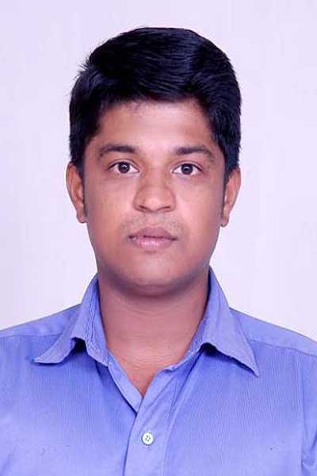
ARAVIND.K
aravind.krishna24@gmail.com Tel-9895429924
9020345483
Career Objective

A progressive position that will fully utilize my attitude and skills in a professional and dynamic organization that promises independent responsibility and bright growth prospects

Professional Summary

An overall experience of around 5.5 years, 3 years in Administration and 2.5 years in HR as Generalists playing a role in Employee Grievances handling,Training, Salary & Wage Processing Recruitment, & HR Operations. Am currently working as HR Executive in Sai Service PVT LTD / NEXA, (Kerala- Region).

Highlights of Roles Performed
- Induction
- Employee Relations
- Training & Development
- Salary & Wage Processing
- Employee Grievances handling
- Talent Acquisition

Experience

Employment Details

15/09/2014 HR Executive, ( NEXA & SAI SERVICE STATION LTD KERALA REGION)
TO
Present Roles and Responsibilities

- Playing a role of a Generalist covering mployee Grievances handling,Training, Salary & Wage Processing Recruitment, & HR Operations.
- Preparing Joining procedures, Joining Offers Letters & Issuing Appointment Letters
- Maintenance of Interview data in the HR Database and generate reports.
- Coordinating processing Monthly Payroll procedures (1200 employees).
- Coordinating Maruti for conducting various training programs including induction training.
- Conducting various Employee engagement activities
- Employee background checks.
- Coordinating for preparing Attrition Reports & Salary Budgeting
- Employee Grievances handling & Coordination with Hod’s and Solving Staff related issues.
- Training & Development
- Administering warning letters on grounds of disciplinary issues .
- Contacting the absconded employees, preparing termination letters, conducting exit interview for the resigned employees
- Recruitment & Selection Process for various branches in Kerala.
- Developing and implementing action plans to keep high motivation level among employees.

04/03/2014 HR INTERN (6 MONTHS INTERNSHIP WITH RR DONNELLEY IN HR OPERATIONS & RECRUITMENT)
TO
27/08/2014 Roles and Responsibilities

• Recruitment & Selection Process, New Hire Updating;
• Taking care of welfare facilities;
• Got an in depth understanding in Employee Data Base Management (People soft)
And Record Maintenance;
• Adding new employees and Updating & deletion existing employees details from
ESI Portal;
• Employee safety, welfare, wellness and health
• Got an in depth understanding in Compensation and benefits administration
• Looking after Employee joining procedures.
19/05/2012 BUSINESS ASSOCIATE ( Muthoottu Mini Financiers PVT LTD)
TO
30/04/2013 Roles and Responsibilities.
- Managing accounting entries of Debentures and Gold loan, Bank book and cash book entries and Administration .
- Collection of cash from clients
- Reporting to the Manager.

03/05/2010 CLERICAL STAFF (AB Marketing PVT LTD)
TO
04/05/2012 Roles and Responsibilities
- Product marketing, stock valuation, Administration and reporting to the proprietor
Career Overview

- Result oriented professional with 4years of extensive experience in financial and managerial fields and Administration and Human Resource.
- Skilled at interfacing and coordinating the work throughout the assigned area, and giving reports to management
- An effective communicator with proficiency in writing, speaking, researching, analysing & logical thinking.

Academic Fact File

- M.B.A (HRM) from Pondicherry University
- Graduated in B.com from Kerala University
- XII , Higher secondary, Sree Vidyadhi Raja Vidya Mandir, ,Kerala,
- X, Board of Public Examinations, St Thomas High School, Kerala.

Technical Skills
MS Office, Photoshop
Certificate Course In Fire & Safety
Valid Light & Heavy License with Badge
Linguistic Skills
English, Hindi, Malayalam
Achievements
Best Recruiter for NEXA from Maruti (Kerala Region)
Participated in Sub-District Levels Competition held at school levels.
Participated in Cyber Graduate Course
Worked as Event Co-coordinator both in School & College Activities

Personal Traits

Good communication and interpersonal skills, highly motivated with strong commitment to teamwork and quality
Excel in knowledge-sharing environment
Positive and having an enthusiastic attitude.
Adaptable to changes
Ability to learn new Technologies
Personal Profile
Nationality : Indian
Age and Date of Birth : 28yrs, 24th March 1988
Mother : Krishna Kumari, (Home – Maker)
ADDRESS
‘AMBADI’
PURAVOORKONAM
KARAKULAM.P.O.
TRIVANDRUM PIN- 695564
Declaration
I hereby declare that the above-mentioned information is correct up to my knowledge and I bear the responsibility for the correctness of the above-mentioned particulars.

Place: Kochi Aravind . K
Date :

